Aim:

To study and ImplementDatabase as a Service on SQL/NoSQL databases like AWS RDS,

AZURE SQL/ MongoDB Lab/ Firebase.

Theory:

Database As A Service:

Database as a service (DBaaS) is a cloud computing managed service offering that provides

access to a database without requiring the setup of physical hardware, the installation of

software, or the need to configure the database. Most maintenance and administrative tasks are

handled by the service provider, freeing up users to quickly benefit from using the database.

DBaaS uses The DBaaS model is ideal for small to medium-sized businesses that do not have

well-staffed IT departments. Offloading the service and maintenance of the database to the

DBaaS provider enables small to medium-sized businesses to implement applications and

systems that they otherwise could not afford to build and support on-premises. Workloads

involving data with stringent regulatory requirements may not be suitable for a DBaaS model.

Furthermore, mission-critical applications that require optimal performance and 99.999% of

uptime may be better suited for on-premises implementation. This is not to say that mission-

critical workloads cannot run on cloud services, but much of the DBaaS adoption to date has

been for less crucial applications, such as development and pilot programs.

Implementation:

**Firebase**

Step 1 :- Goto Firebase console

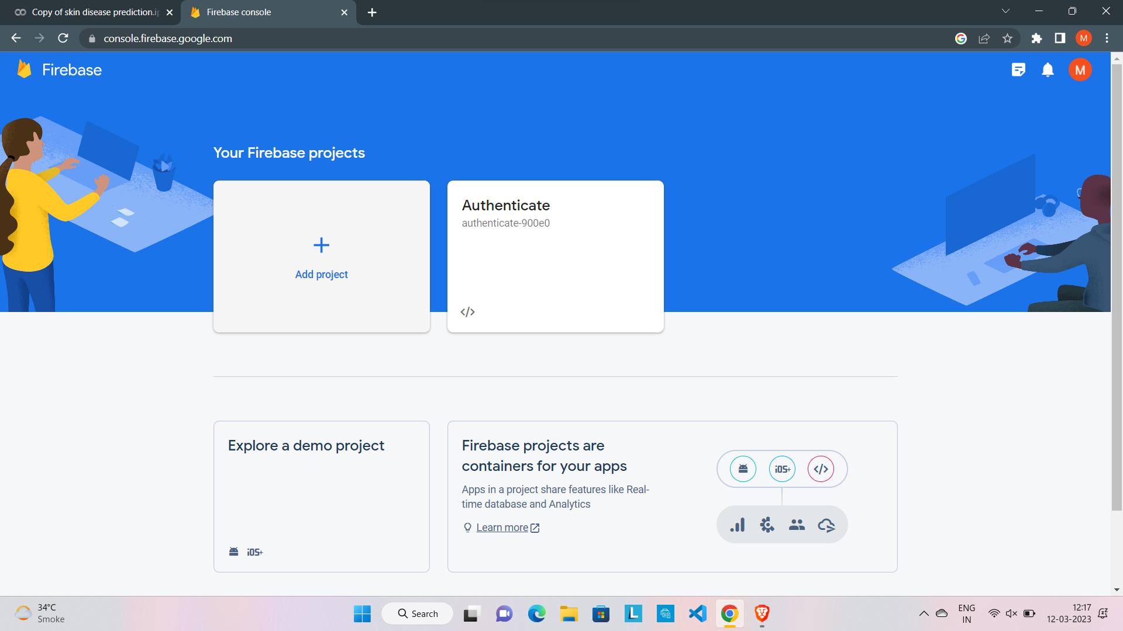

Step 2 :- Click on add project

Step 3 :- Enter few details like project name

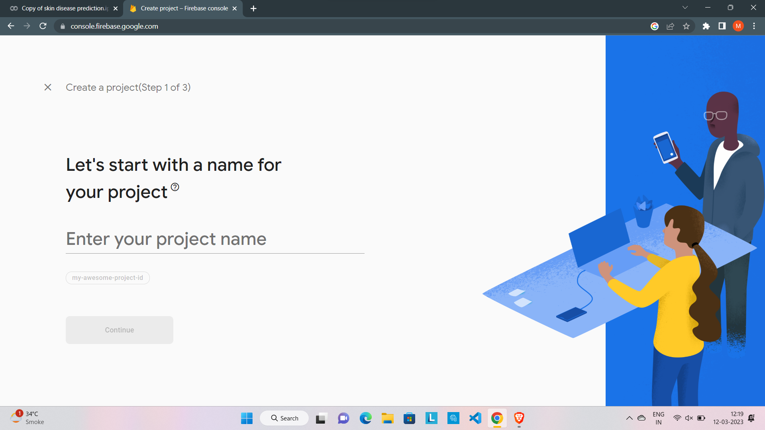

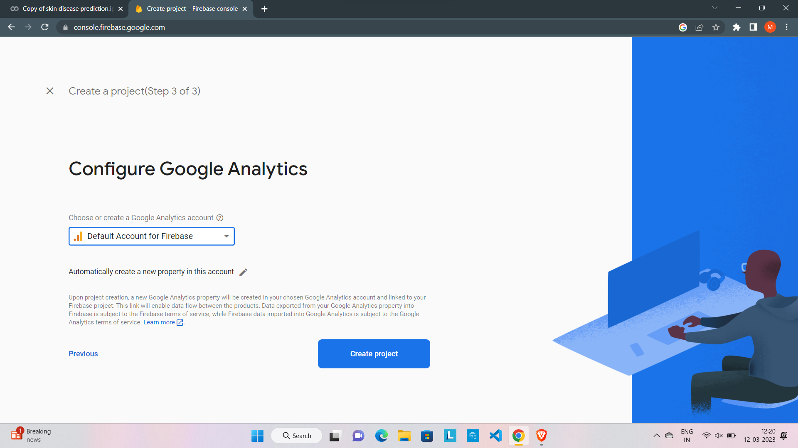

Step 4:- Database Project is created successfully now click on realtime database option

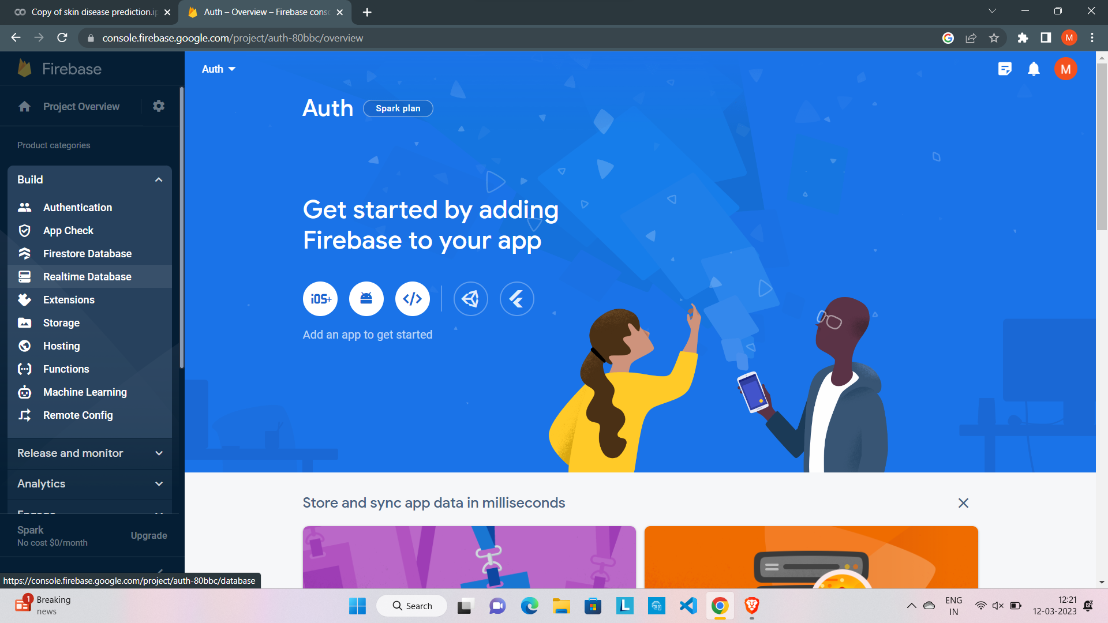

Step 5 :- Click on create database project

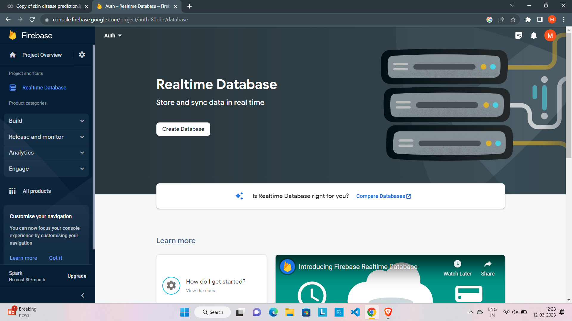

Step 6 :- Database is created we can add data in database

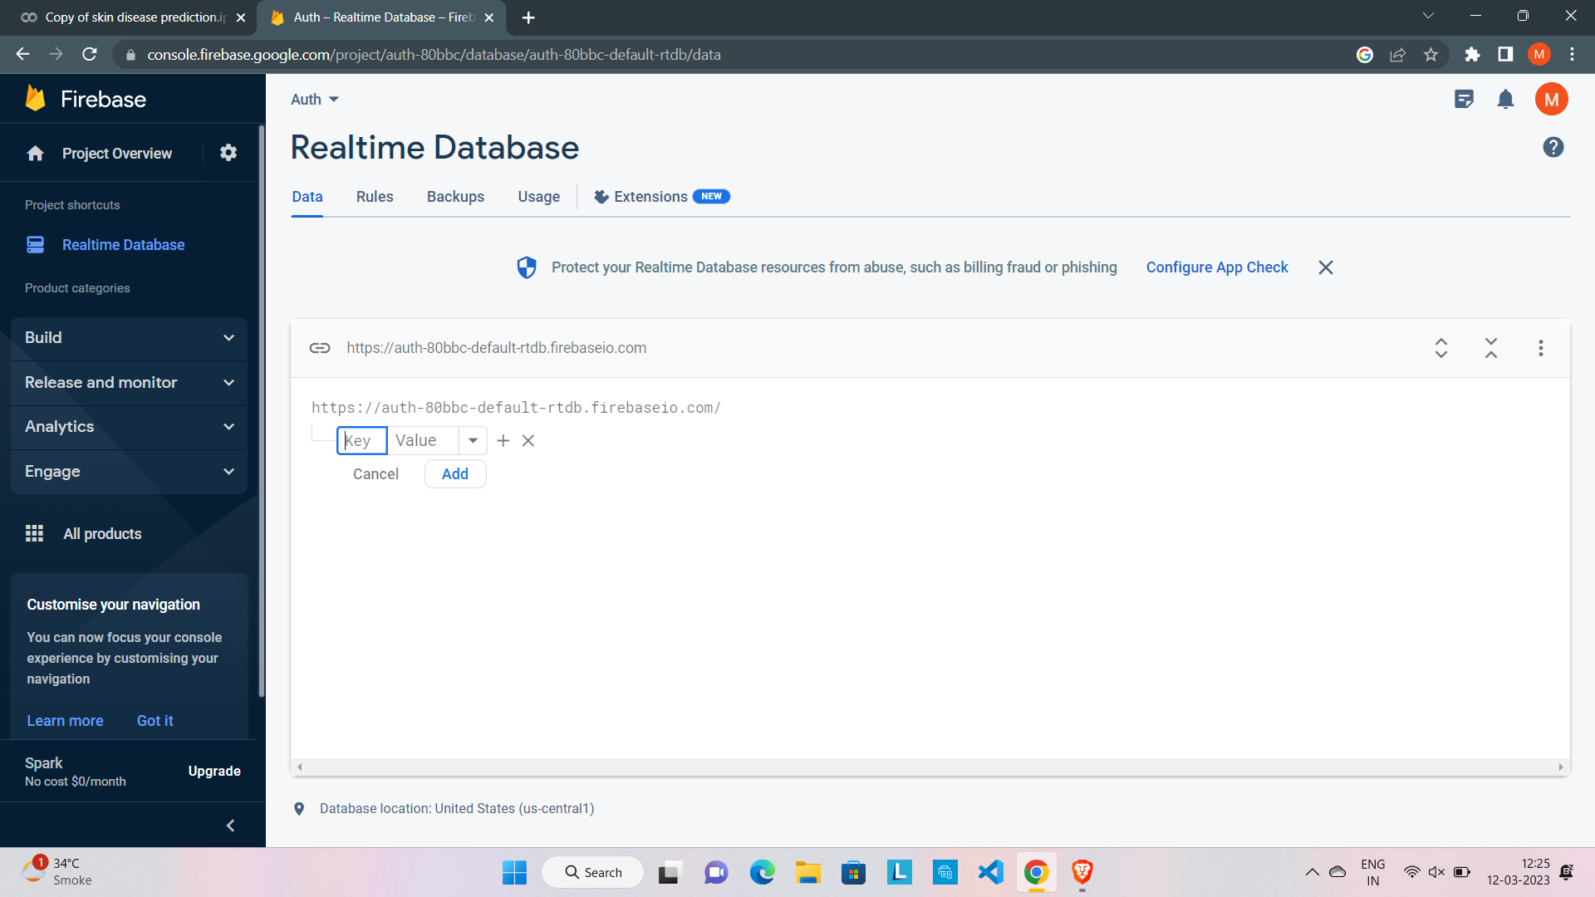

Step 7 :- Data inserted

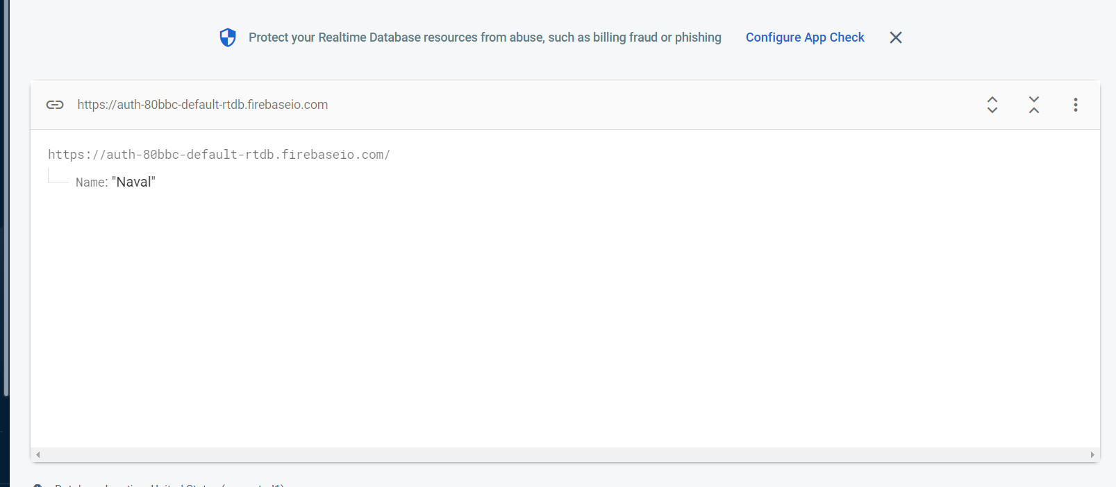

Step 8 :- Data updated in database

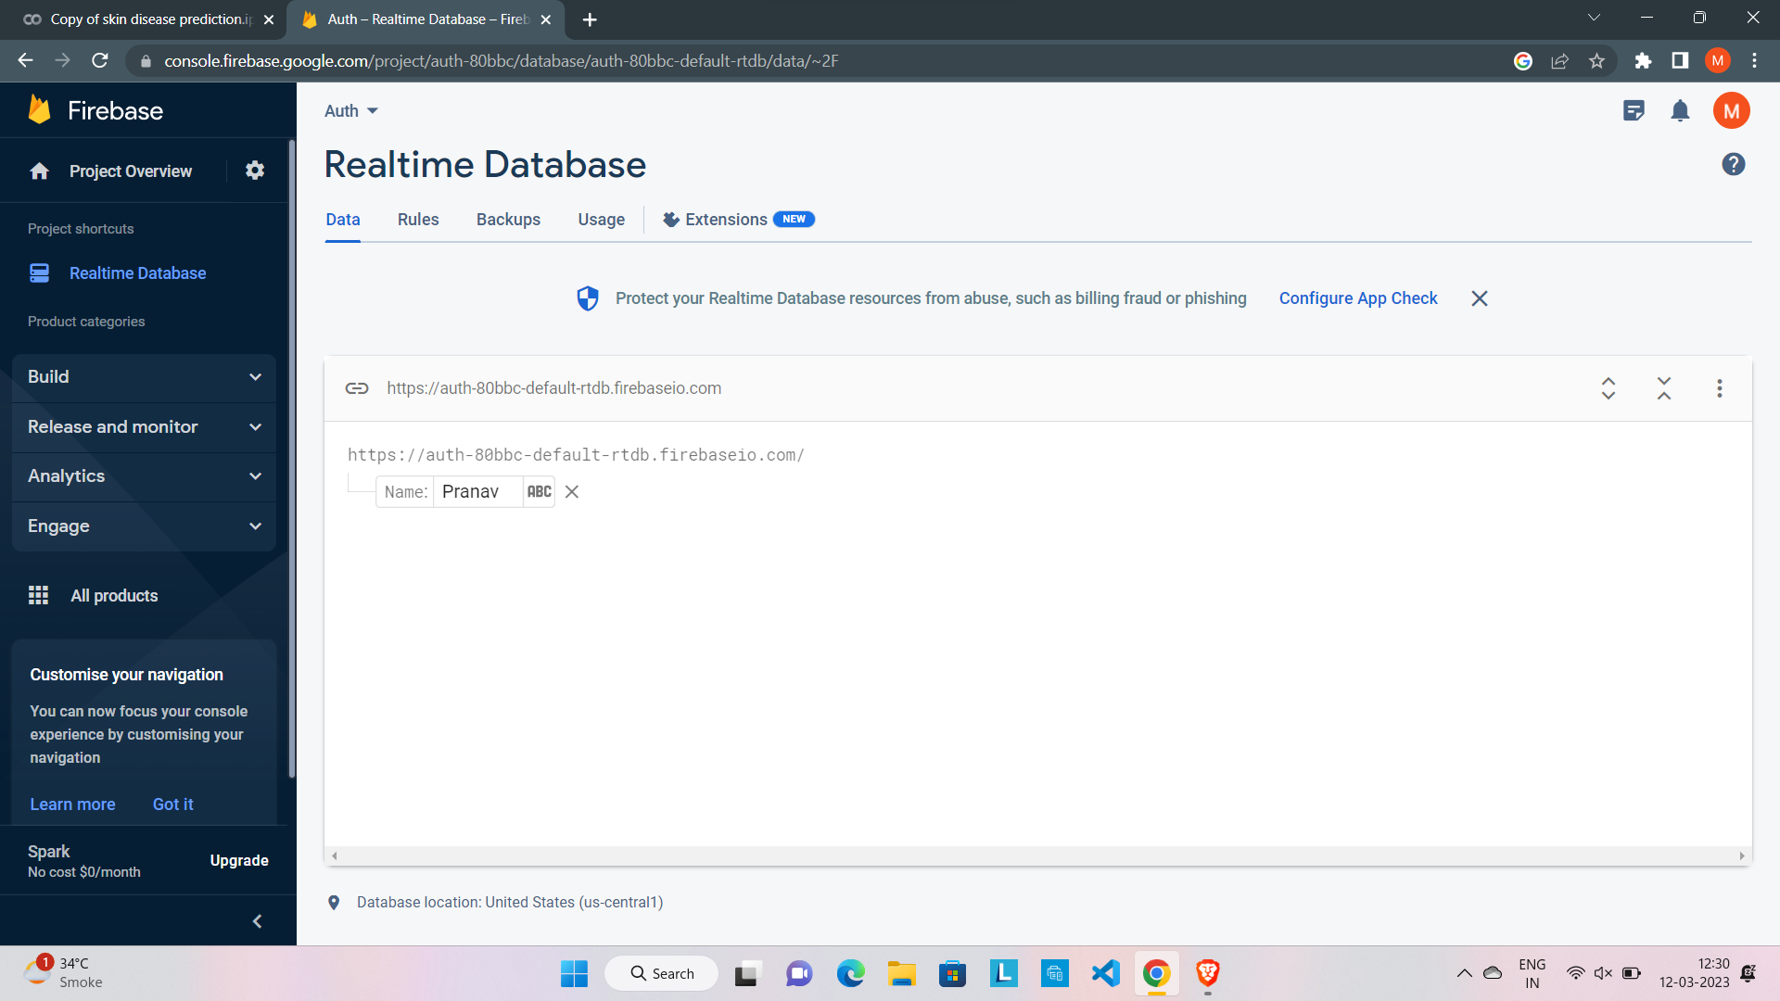

Step 9 :- Data deleted in database

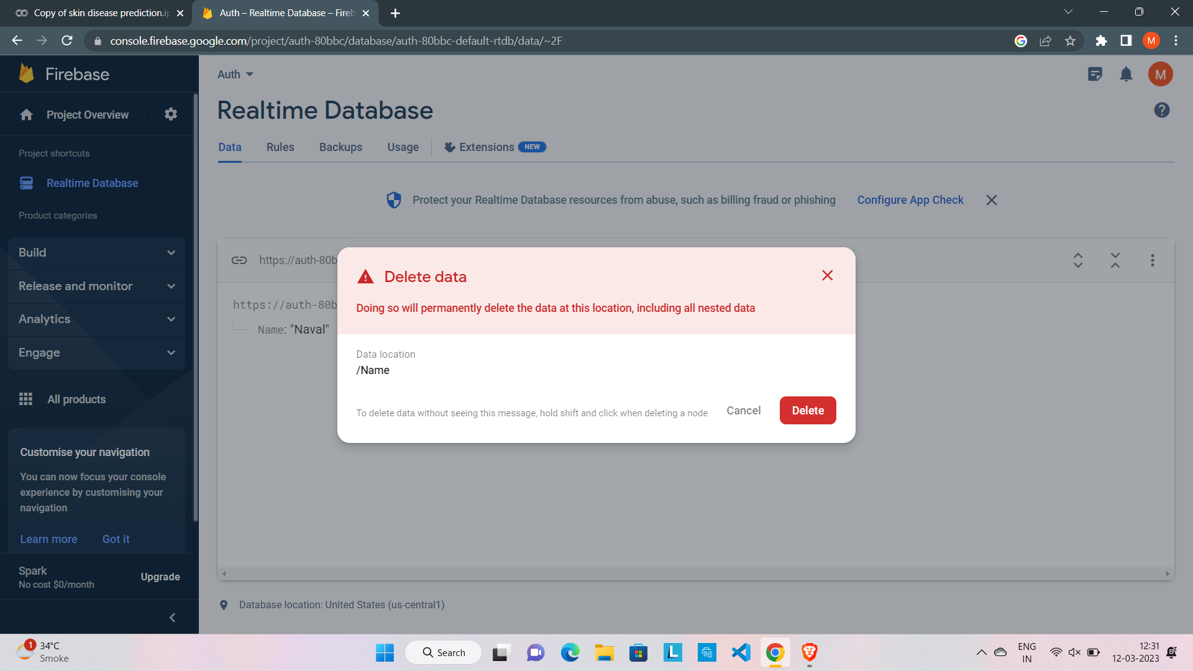

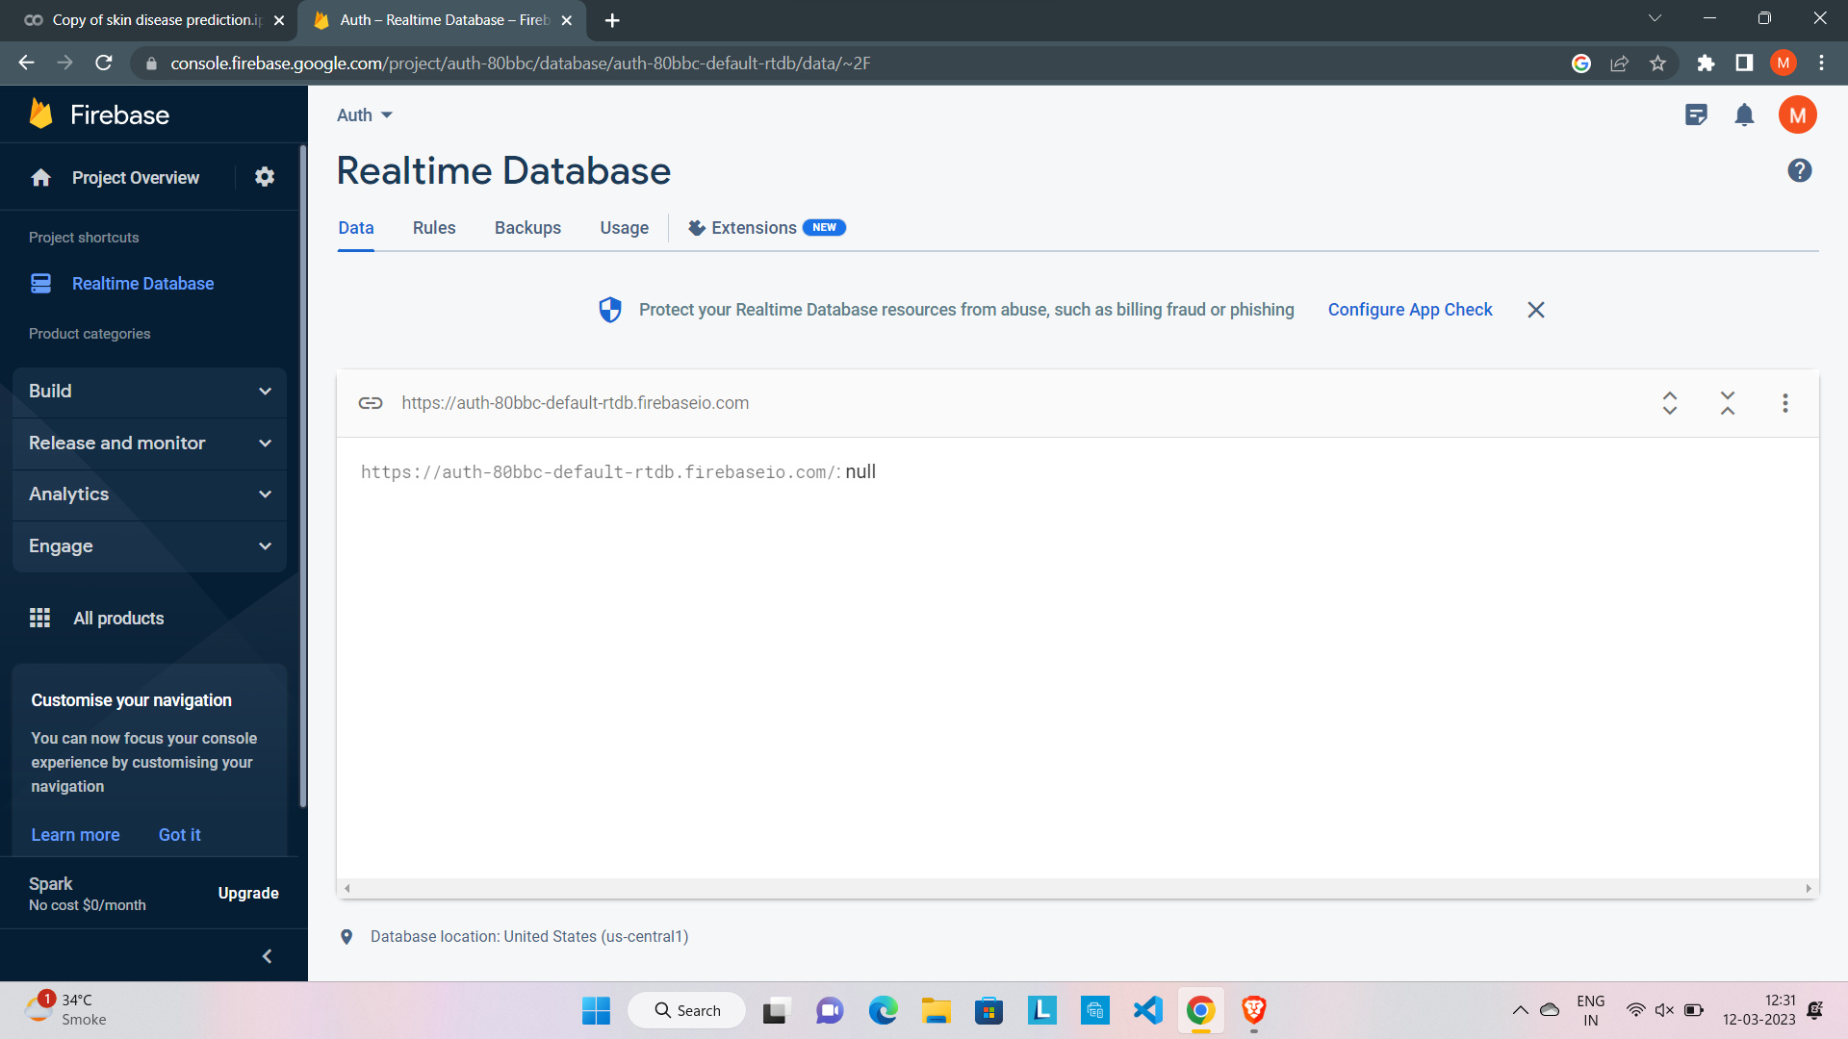

Conclusion:

In this experiment we implemented DBaaS using firebase service which is provided by Google and is a real time database it stores data in json format i.e. No SQL format.